## Configuring the Load Balancer

### Lab Overview

In this lab, you will create a new load balancer resource and a public static IP address. The web virtual machines created earlier will be added to the back end pool of the load balancer.

### Exercise 1: Create the Load Balancer

1. While logged into **LABVM**, open the Azure portal (https://portal.azure.com). Click **New** in the upper left hand corner. In the search menu type **Load Balancer**. Click to select the first option.

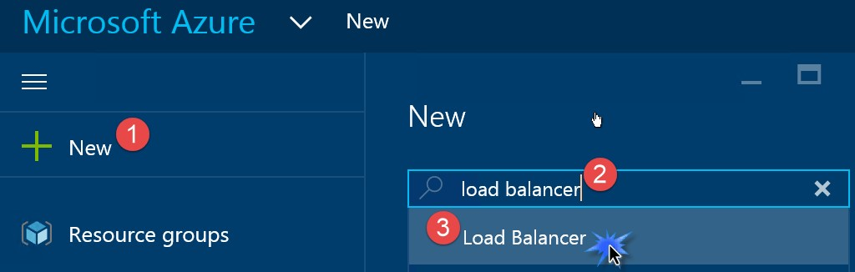

1. In the chooser dialog that opens, choose the **Load Balancer** with Microsoft listed as the Publisher.

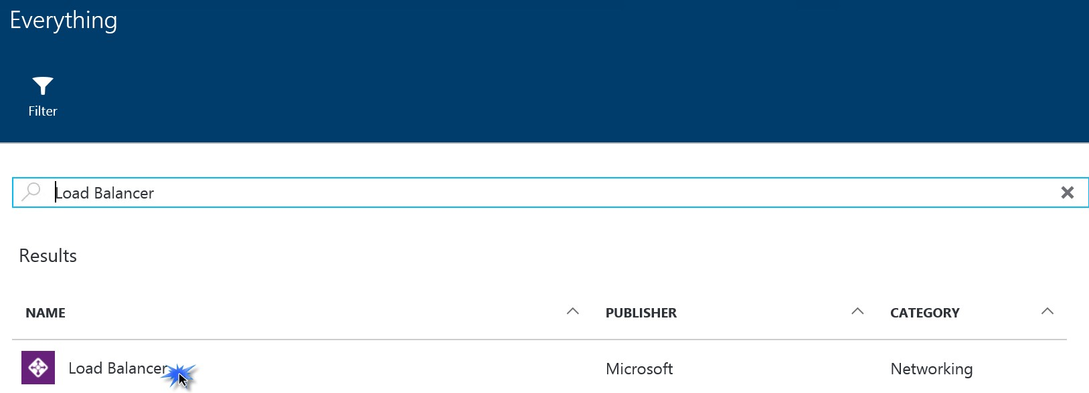

1. In the dialog that opens, click **Create** at the bottom.

1. In the Create load balancer dialog, enter **OPSLB** for the name. Leave the **Scheme** set to **Public**.

1. Click **Choose a public IP address** then click **Create new**.

1. Enter the name **opsstaticip** for the public IP name and leave the **Assignment** set to **Static**. Then click **OK.**

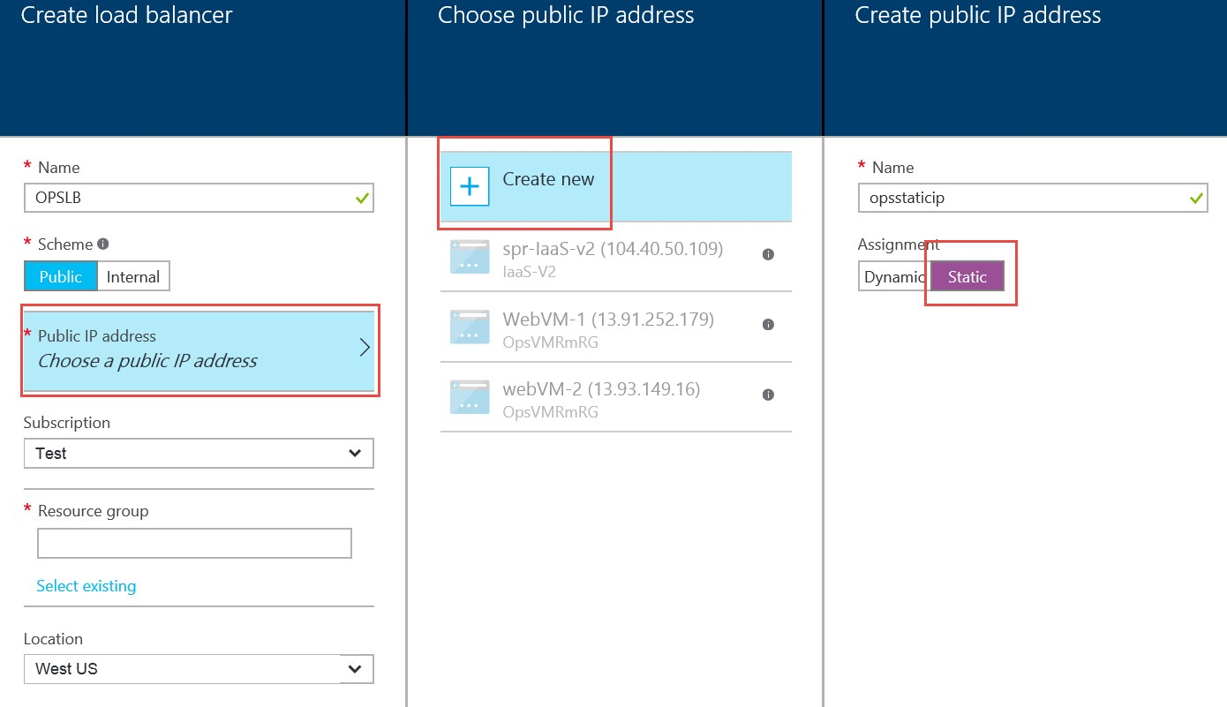

1. Ensure the correct subscription is selected. Under Resource group click the drop down list and choose **OpsVMRmRG** from the listing of Resource Groups to choose from.

1. Ensure the **Location** is set to the same location used throughout this lab, then click **Create**.

### Exercise 2: Configure the Load Balancer

1. While logged into **LABVM**, open the Azure portal. Click on **More Services**.

1. In the **filter** box at the top type in **Load**. The list will filter and only display **Load Balancers**.

1. Click **Load Balancers**.

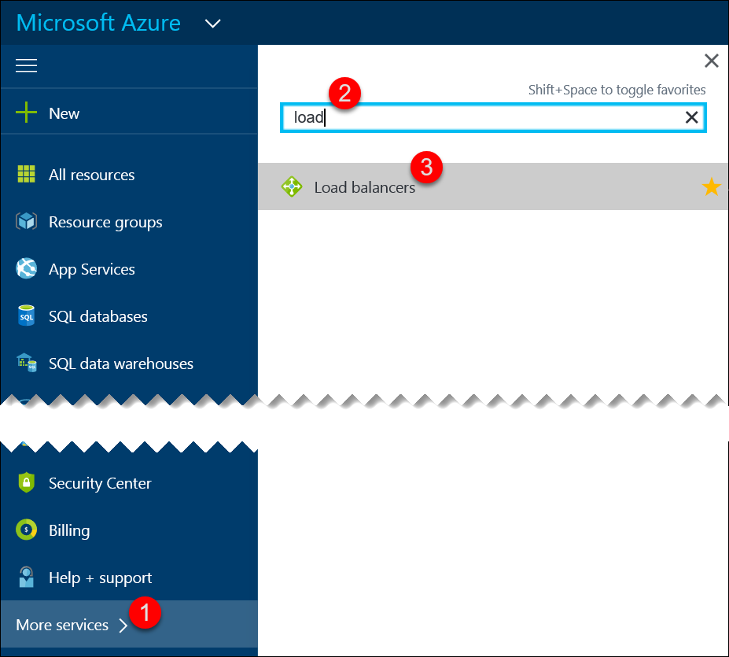

1. In the Load balancers dialog click on **OPSLB**. The settings for **OPSLB** are displayed. Click **Backend pools** and then click **Add** at the top.

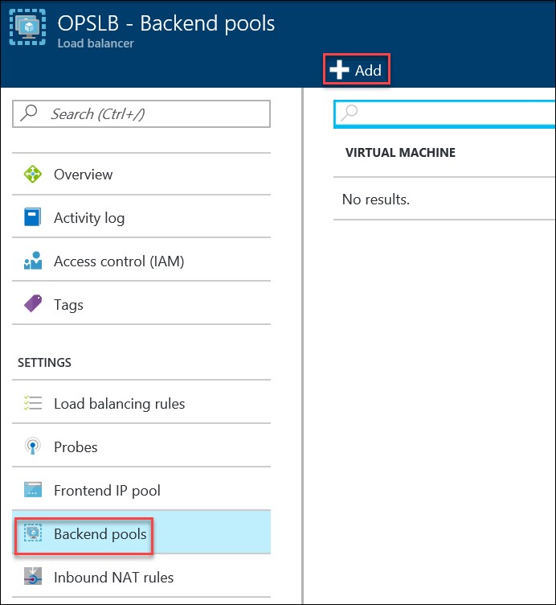

1. Enter **LBBE** for the pool name.

1. Click **Add a virtual machine**.

1. Click **Choose an availability set**.

1. Click **WebAVSet**. This is the availability set that was created when the Web servers were created earlier in the lab.

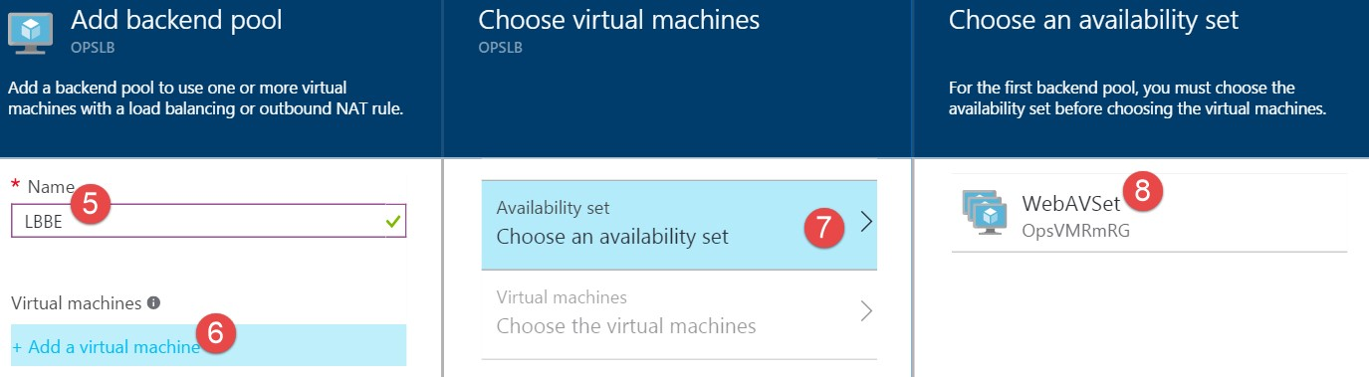

1. Back on the **Choose virtual machines** blade, click **Choose the virtual machines**. Select both web VMs and click **Select** at the bottom.

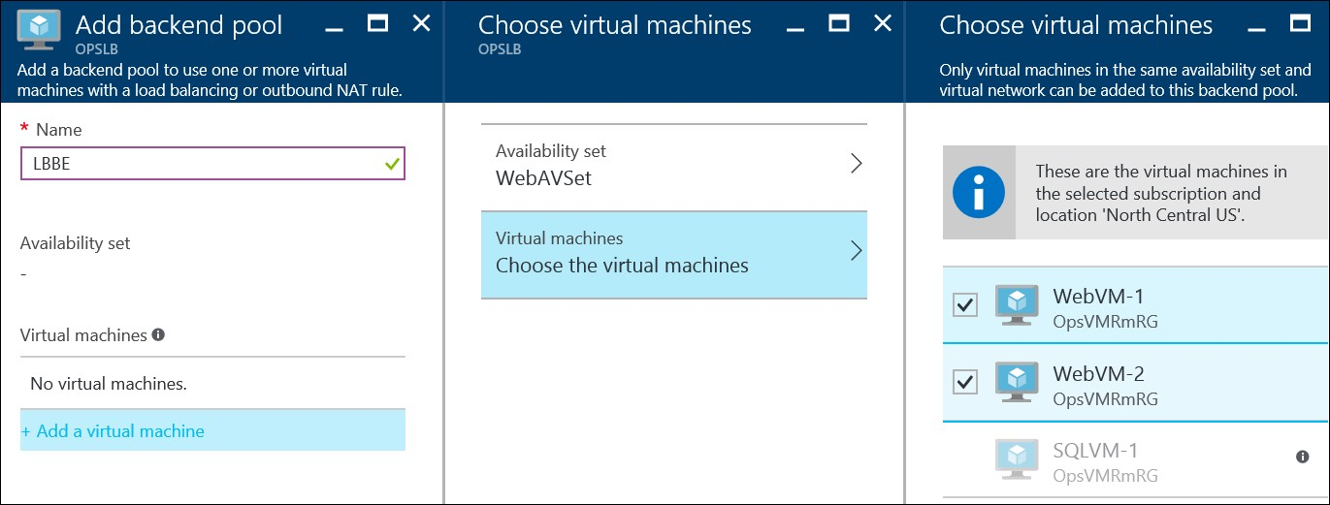

1. Click **OK** on the **Choose virtual machines** blade and **OK** on the **Add backend pool** blade.

After a few minutes you should see a success status.

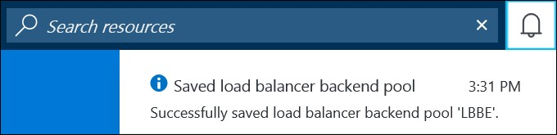

1. Back on the **Settings** blade forthe load balancer click **Inbound NAT** **rules**.

1. On the **Inbound NAT rules** blade click **Add**. Configure the **Add inbound NAT rule** blade like below.

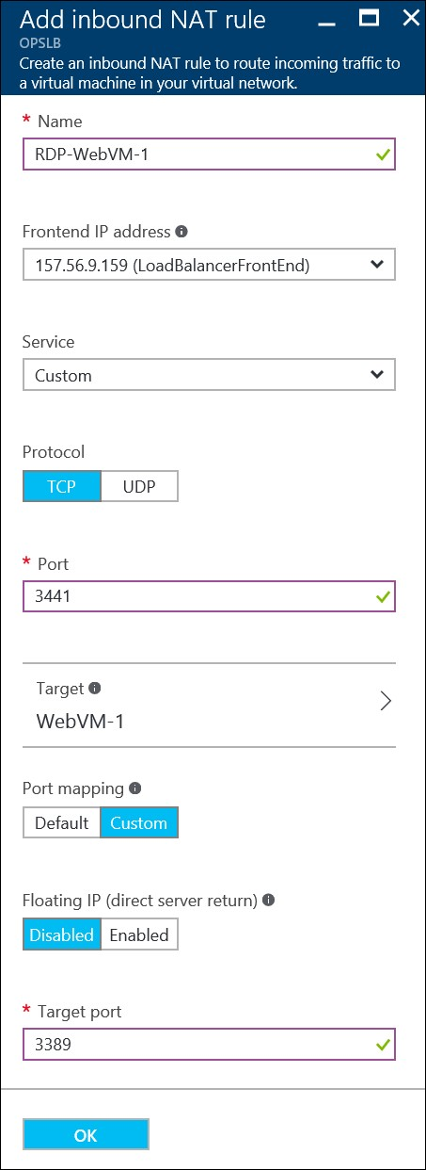

1. Click **OK** to create the rule. After a couple of minutes, this operation will complete. Then proceed to the next step.

1. Click **Add** once more. Create another **inbound NAT rule** with the below configuration and click **OK** to save it.

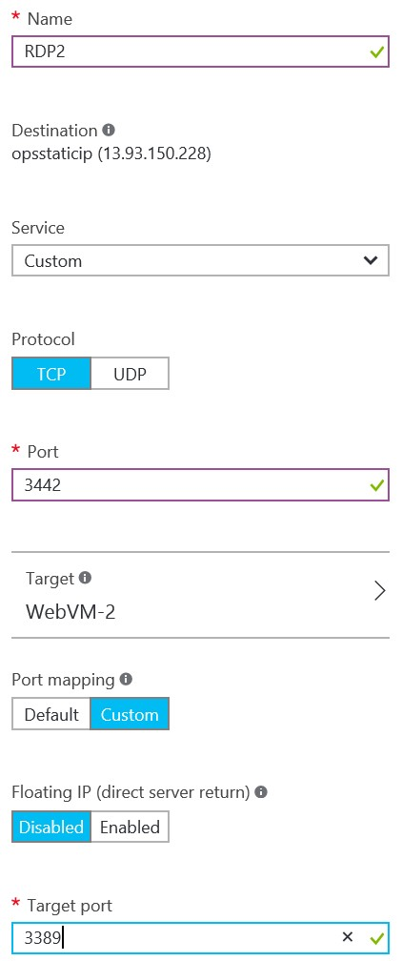

1. Next, in the **Settings** tab click on **Probes**. Click **Add**, use the below information to create a health probe, then click **OK** to create the probe.

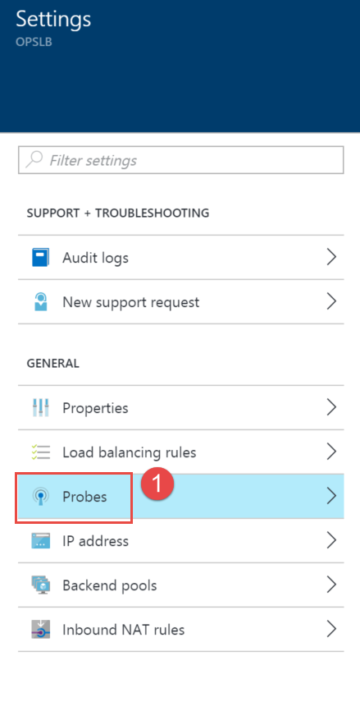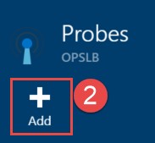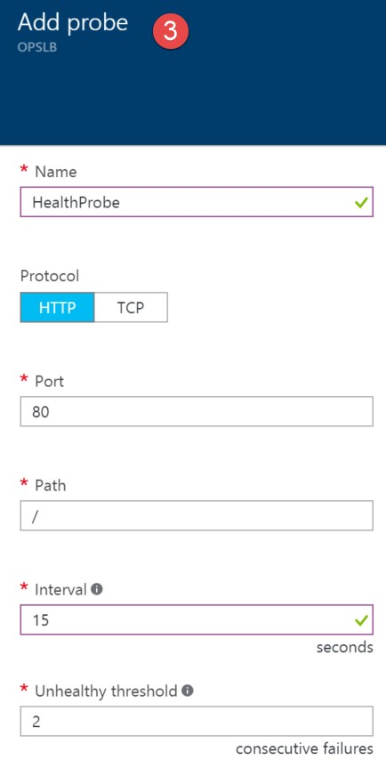

1. Back on the **Settings** blade click **Load balancing rules**. Click **Add** at the top of the **Load balancing rules** blade, complete the configuration as shown below, and then click **OK**.

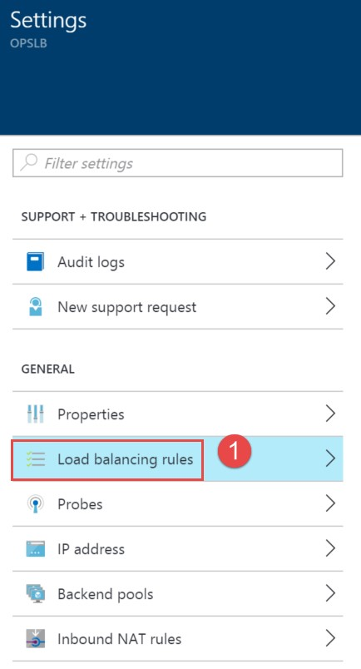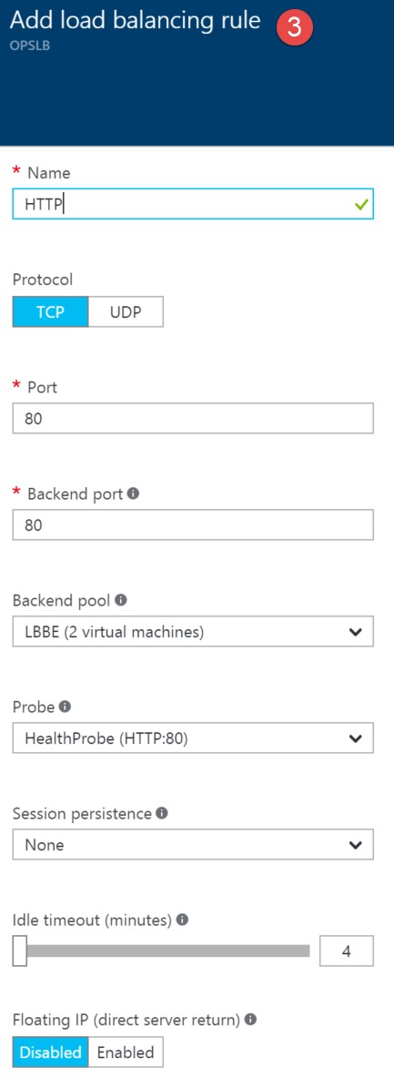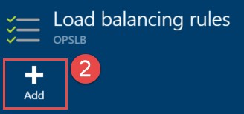

1. Close the **Load balancing rules** and **Settings** blade. The essentials panel shows you a high level view of how many virtual machines are in the backend pool, the public IP address associated with it as well as the number of NAT rules. Note the IP address as you will use it shortly to validate the load balancer.

1. Validate the load balancer is working by launching a browser instance and navigating to the public IP address of the load balancer. **Refresh** the page several times until you see a response from **WebVM-1 and WebVM-2**.



### Exercise 3: Configure Diagnostics for the Azure Load Balancer

1. 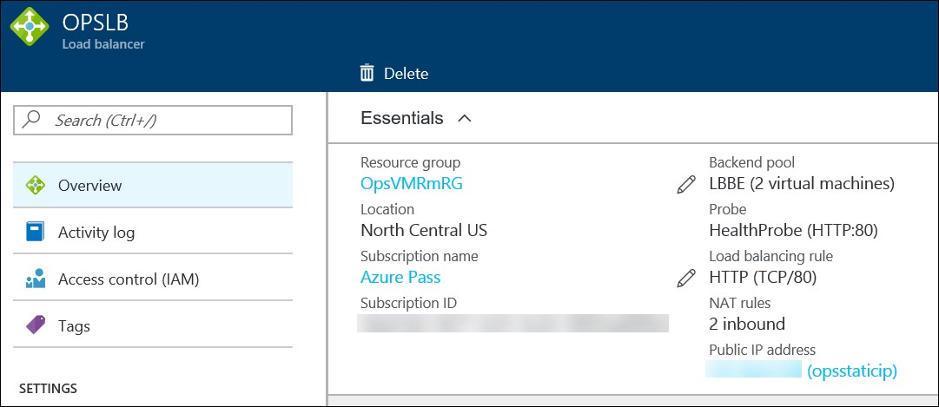In the Azure Management Portal, click **Browse**, **Load balancers**, and then click the **OPSLB** load balancer.

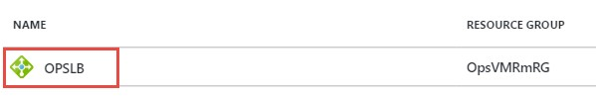

1. On the Settings Pane, click **Diagnostics**.

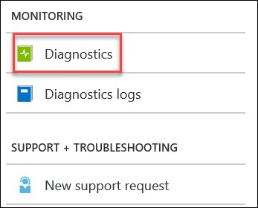

1. Enable Diagnostics on the load balancer by changing the Status to **On**, selecting a **Storage Account** (use the same one as your virtual machines for this lab), and then enable logging for the **LoadBalancerAlertEvent** and **LoadBalancerProbeHealthStatus** diagnostic sources. Click **Save** to continue.

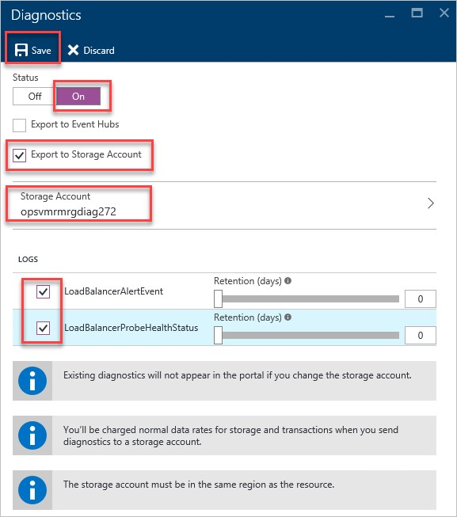

Note 1: Similar to virtual machine diagnostics, load balancer diagnostic data is store in Azure Storage Tables and is accessible using tools like Visual Studio or 3rd party management tools like Azure Management Studio. It may take up to an hour for any data to appear.

Note 2: At the time of this writing (2/2/2016) diagnostics logs are only applicable to load balancers listening on a public IP address.

1. Verify the load balancer alert works by stopping **WebVM-2**. Click **Browse**, **Virtual Machines**, **WebVM-2**, and click **Stop**.



1. Come back to this exercise in at least 1 hour so the diagnostics agent can synchronize the failure to Azure Storage. From Storage Explorer or Azure Management Studio navigate to the diagnostics storage account -> Blob Containers \ insights-logs-loadbalancerprobehealthstatus and expand the path down to the PT1H.json file.

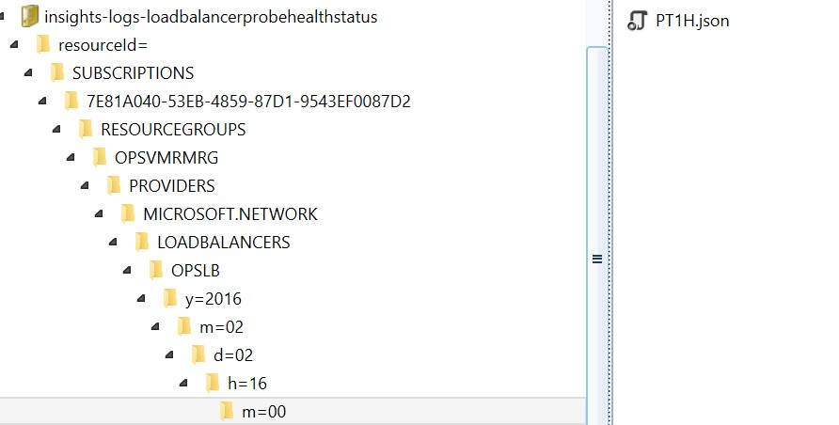

The record will show that the “dipDownCount” is set to 1 (meaning that the private port is not responding to the load balancer health probes).

Lab

Summary

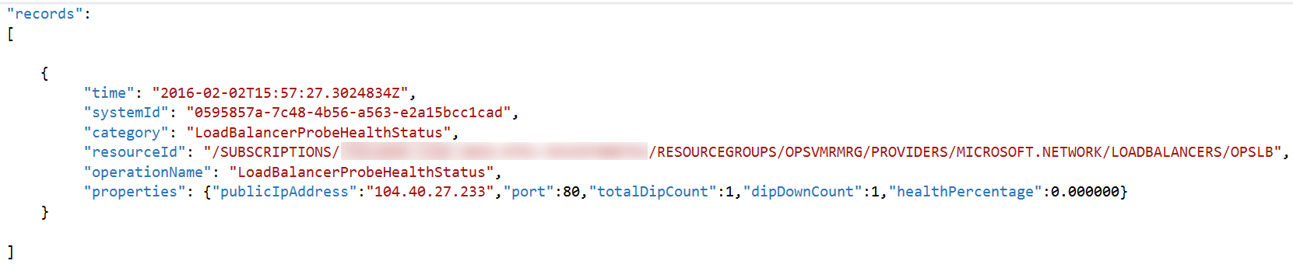

In this lab, you created a new load balancer resource and a public static IP address. The web virtual machines created earlier were added to the back end pool of the load balancer.